Module 8: Focus on Java: Improving Application Reliability in Java
James Patrick Siruno
Colorado State University Global
Course Code: CSC450 Programming III
Rusell Frith
03/10/2024

- Output
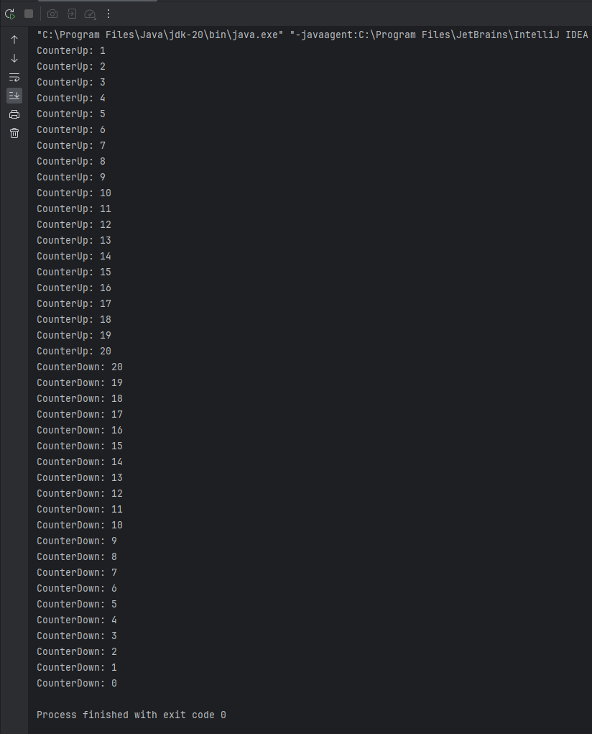
2. Source code:
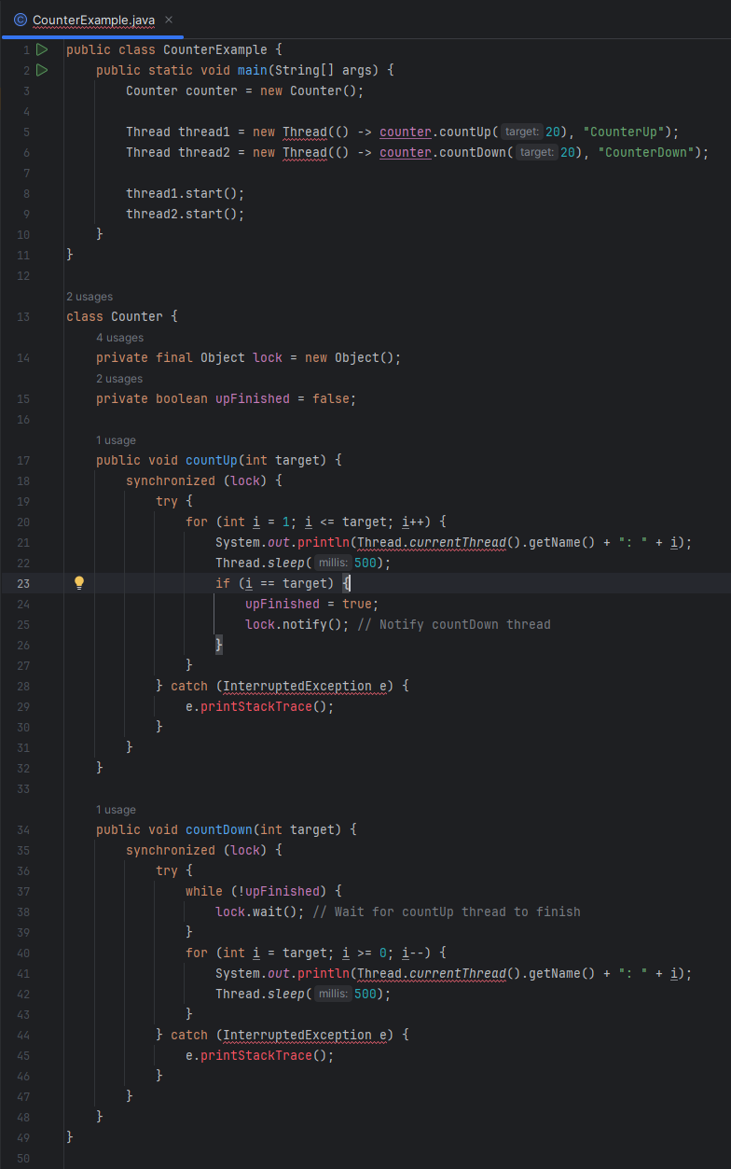
- Analysis
Performance issues with concurrency:
Concurrency introduces potential performance issues due to contention for shared resources, such as the synchronized lock in the provided code. While synchronization ensures thread safety, it can lead to contention and performance degradation, especially if threads spend significant time waiting for locks. Fine-tuning the synchronization mechanisms, using lock-free algorithms where applicable, and minimizing the scope of synchronized blocks can mitigate these performance concerns. Additionally, utilizing thread pooling and asynchronous processing techniques can improve overall system throughput and responsiveness.

Vulnerabilities exhibited with the use of strings:
The usage of strings in the provided code may lead to vulnerabilities such as string manipulation vulnerabilities (e.g., buffer overflow, injection attacks) if the input strings are not properly sanitized or validated. In the given context, where strings are used for thread names and printing messages, there might not be immediate security risks. However, in a real-world application, if strings are obtained from untrusted sources (e.g., user input, network data), proper input validation and sanitization should be performed to prevent attacks such as SQL injection, cross-site scripting (XSS), and command injection.

Security of the data types exhibited:
In the provided code, the primary data types used are integers (int). While integers themselves do not pose inherent security risks, improper handling or manipulation of integer values could lead to vulnerabilities such as integer overflow/underflow, which might be exploited for security breaches. For example, if integer values derived from user input or external sources are not properly validated and sanitized, they could potentially be manipulated to cause unexpected behavior or security vulnerabilities. To mitigate such risks, proper input validation, range checks, and secure coding practices should be employed when dealing with integer data types.

References:
Goetz, B., Peierls, T., Bloch, J., Bowbeer, J., Holmes, D., & Lea, D. (2006). Java Concurrency in Practice. Addison-Wesley Professional.
Viega, J., & Messier, M. (2003). Secure Programming Cookbook for C and C++. O'Reilly Media.
McGraw, G., & Viega, J. (2002). Building Secure Software: How to Avoid Security Problems the Right Way. Addison-Wesley Professional.

